Practice Problems

2. As part of a larger experiment, 9 three-month-old infants were randomly divided into three groups of three infants each. The infants in a group were repeatedly shown one of three multicolored designs, A, B, and C. The average time in seconds spent watching the design was recorded for each infant with the following results:
A | B | C
10.6 | 8.5 | 7.9
12.3 | 9.6 | 6.9
11.1 | 7.4 | 6.6

- Both symbolically and in words state the null and alternative hypotheses

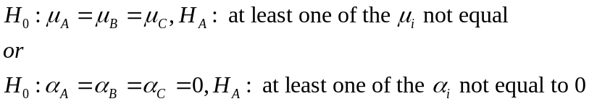

H₀: There are no differences in the average time 9-month-old infants watch three different multicolored designs.
H_{A}: There are differences among the average time 9-month-old infants watch three different multicolored designs.
- Fill in the following ANOVA Table (include both equations and actual numbers) (make sure all empty boxes are filled)
Source | Df | SS | MS | F
Treatment | a-1=3-1=2 | 27.535556 | TrtSS/df=  27.535556/2=13.7678 | MSTrt/MSE=13.7678/0.8122=16.95
Error | a(n-1)=3(3-1)=6 | 4.873333 | ESS/df=4.873333/6=0.8122 | -----
Total | an-1=3*3-1=8 | Trtss+Ess=32.4089 | ----- | -----
- Based on your results and an α=0.05, circle the correct F value you need to use to compare your calculated F

- Based on your results what can you conclude based on the researcher’s original question?
At least two of the average times 9-month-old infants watch three different multicolored designs are significantly different.
3. A consumer organization suspects an unusual difference in the recorded use of electricity by homeowners in two different cities. They obtained data on the number of kilowatt hours (KWH) for n=12 homeowners in City A and n=8 homeowners in City B. Summary data based on the two samples that they collected are computed as follows:
 |  |  | N
City A | 33.0 | 67.7 | 12
City B | 29.7 | 45.9 | 8
- Calculate the pooled variance.

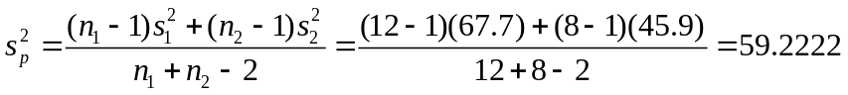
- Find and interpret a 90% confidence interval for the mean difference in KWH used between the 2 cities.

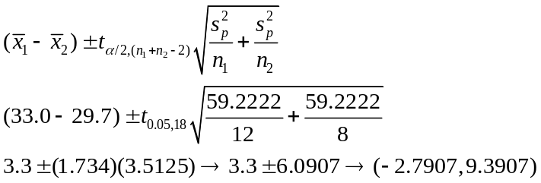
We are 90% Confident that the true mean difference in KWH used between the two cities falls between -2.7907 and 9.3907 KWH.
- Based on your results, what can the consumer group conclude based on their original question?

Since 0 falls in the 90% confidence interval, the consumer group can conclude that there is not a difference in the KWH used between the two cities.
- What assumption did you make in order to use the pooled variance?

We assume that the variances for the two populations are equal

- Test to see if the variances are equal. 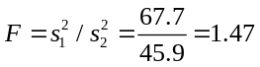
Note that on a problem like this, you would be given the F value (or selection of F values to choose from to compare).
The main thing to remember that the degrees of freedom are
.

Because this is a two-tailed test, we need to find both the upper and lower tailed values. So we look up the value in Table A.12c for the upper tail and A.12h for the lower tail.

So the rejection region at =0.050 is for the upper tail 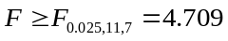 .

For the lower tail we use the helpful hint 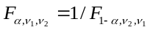 and find the rejection region is

The computed 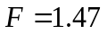 falls between 0.266 and 4.709, so we fail to reject the null hypothesis and conclude that the variances are equal.
4. In a particular calibration study on atomic absorption spectroscopy the response measurements were the absorbance units on the instrument in response to the amount of copper in a dilute acid solution. Five levels of copper were used in the study. The following table shows the results
Copper (mg/ml)
0.00 | 0.05 | 0.10 | 0.20 | 0.50
0.045 | 0.084 | 0.115 | 0.183 | 0.395
0.047 | 0.087 | 0.116 | 0.191 | 0.399
0.051
0.054

- Plot the data on a graph. Make sure to label both axes.
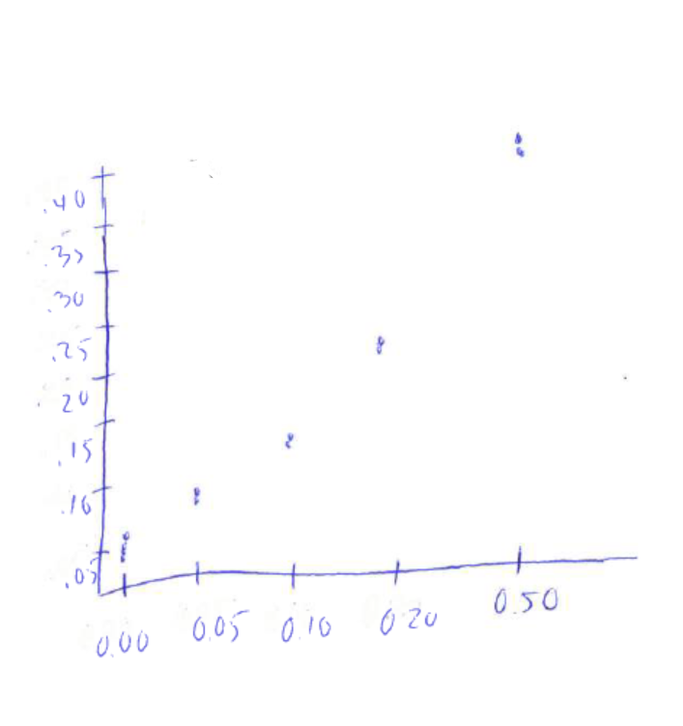
- Based on your plot, justify why or why not you think there are differences in the absorption level among the different levels of copper

Yes, there are differences in the absorption levels among the different levels of copper. None of the values at the different levels overlap. In fact, there are big gaps in the levels, indicating very big differences among the means.
- Fill in the following ANOVA Table (include both equations and actual numbers) (make sure all empty boxes are filled)

Source | Df | SS | MS | F
Treatment | a-1=5-1=4 | 0.17596850 | TrtSS/df=0.1759685/4  =0.04399212 | MSTrt/MSE=  0.043299212/0.0009375  = 3284.75
Error | 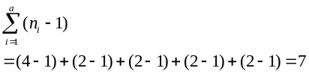 | 0.00009375 | ESS/df=0.00009375/7  =0.00001339 | -----
Total | 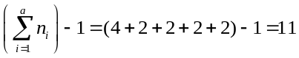 | Tss+Ess=0.1761 | ----- | -----

- Based on your results and an F value from the F distribution at α=0.001 of 18.772, what can you conclude based on the investigator’s original question?
We can conclude that there are significant differences in the absorption level among the different levels of copper.

- Please note that we will cover the material for this on Friday!
In order to investigate whether four different fats are absorbed in different amounts by a doughnut mixed during cooking, uniform batches of doughnuts were cooked on 6 different days in each of the 4 fats and the amount of fat absorbed by each batch was recorded.

- Write out the linear additive model for this study and define the terms
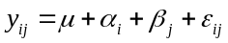
Where 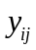 is the fat absorbed by a batch of doughnuts cooked in the ith fat on the jth day.
 overall mean fat absorbed
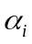 effect due to fat i.
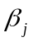 effect due to day j.
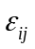 denotes a random error associated with the jth observation from population i. We assume that is normally distributed with mean 0 and a variance of .

- Fill in the following ANOVA Table
Source | Df | SS | MS | F
Day | b-1=6-1=5 | MS*df=5*77.375  =386.875 | 77.375 | 77.375/39.095=1.98
Fat | a-1=4-1=3 | MS*df=3*181.1528  =543.4584 | 181.1528 | 181.1528/39.094=  4.634
Error | (b-1)(a-1)=15 | 585.2917 | SS/df=  585.2917/15=39.094 | -----
Total | ab-1=23 | 1515.6251 | ----- | -----
- Circle which one of the F values above that you would use to compare your F value for Fat.
The one to use is 3.287
- Based on an α=0.05, what can you conclude based on the original research question?
Because our F is greater than the table F, we reject the null hypothesis and conclude that there are differences among the four types of fat in the amount of fat absorbed per batch of doughnuts.
- Does it appear that blocking by day was effective? Support your answer.
Because the F value is less than the table F, it would appear that blocking by day was not effective.

- A school district wants to examine whether there is a difference between the schools in terms of attendance rate. They are particularly interested in School A, B, C, and D. In School A and School B they started a program where they award students who don’t miss school, and they have more field trips. They randomly choose 3 classes, and record the total number of hours students missed in the previous year. The data are given below.
 | School A | School B | School C | School D
 | 58 | 11 | 61 | 70
 | 72 | 40 | 90 | 90
 | 54 | 65 | 66 | 100
Mean hours:
The R output of the ANOVA table is given below:
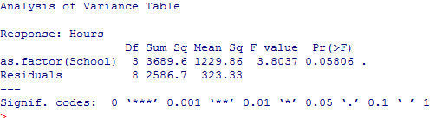
- At α=0.1 level is there a significance difference among the 4 schools in terms of attendance rate? Write down your hypothesis, and using the output write your decision and conclusion.
- Write down the linear contrast for comparing School A and B with School C and D. Show that it is actually a linear contrast.
- Using the F table test whether this contrast is significant. Don’t forget the conclusion.
- Perform Fisher’s protected LSD for all pairwise comparison.
- Calculate Scheffe’s S for the comparison in part b. Don’t forget your conclusion.

